# pipeline : deploying html file on httpd server
-Anushka Vijay Gaikwad

- Launched a JM
- Create a pipeline job for installing httpd and deploying index.html file on server

pipeline {

agent {

label {

label "built-in"

}

}

stages {

stage ("one") {

steps {

sh '''

rm -rf *
yum install httpd -y
systemctl start httpd
echo "httpd started" >> /var/www/html/index.html
chmod 777 /var/www/html/index.html

'''
}
}
}

}

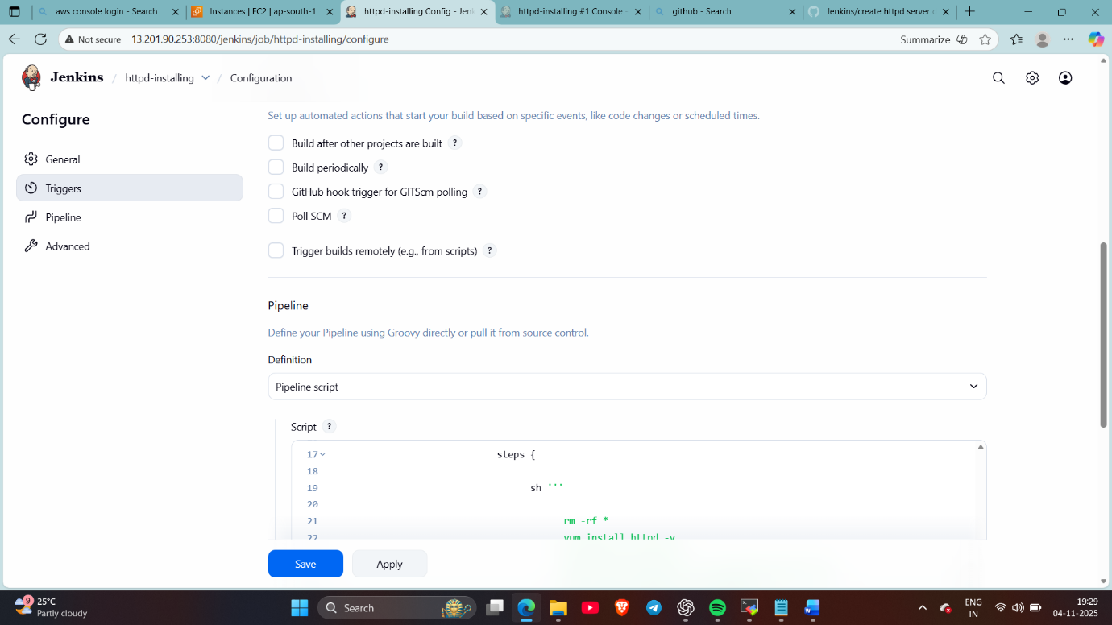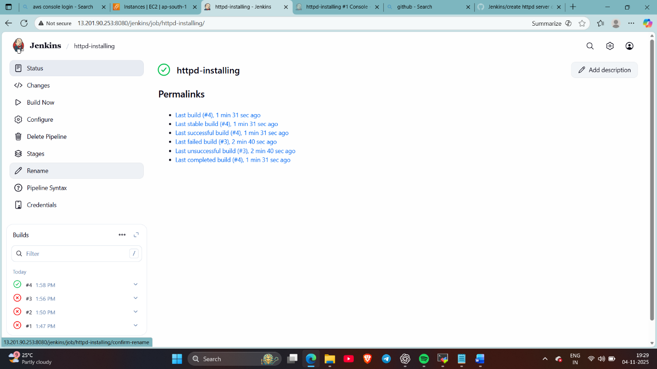
Checked ..
done

